# [**NBC Renewal Status Report: One Chicago, ‘Law & Order’ Franchise, ‘Lopez vs. Lopez’, ‘American Auto’ & More**](https://deadline.com/2023/03/nbc-canceled-renewed-chicago-fire-pd-med-law-order-svu-organized-crime-lopez-vs-lopez-american-auto-1235309250/)



By [Nellie Andreeva](https://deadline.com/author/nellie/)

## [**Nellie Andreeva**](https://deadline.com/author/nellie/)

*Co-Editor-in-Chief, TV*

[@DeadlineNellie](https://twitter.com/DeadlineNellie)

#### **More Stories By Nellie**

* [‘Clone High’ Revival On HBO Max Sets Spring Debut, Reveals Cast & First-Look Images](https://deadline.com/2023/03/clone-high-revival-hbo-max-premiere-date-cast-first-look-images-1235310030/)
* [CBS Renewal Status Report: ‘Blue Bloods’, ‘S.W.A.T.’, ‘East New York’ & ‘True Lies’](https://deadline.com/2023/03/cbs-canceled-renewed-blue-bloods-swat-east-new-york-true-lies-1235309754/)
* [‘Grey’s Anatomy’ Renewed For Season 20 By ABC – Will Ellen Pompeo Return?](https://deadline.com/2023/03/greys-anatomy-renewed-season-20-ellen-pompeo-return-1235309800/)

[**VIEW ALL**](https://deadline.com/author/nellie/)

March 24, 2023 2:00pm

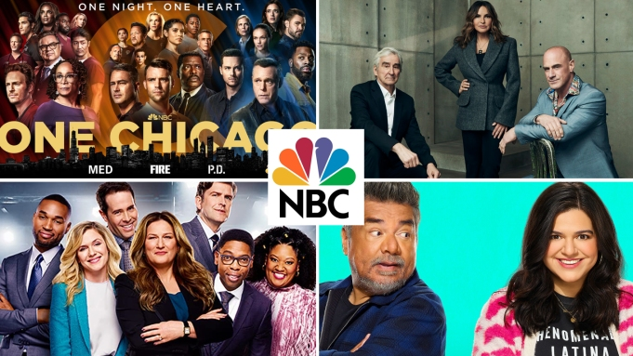[**STORY ARC**](https://deadline.com/2023/03/nbc-canceled-renewed-chicago-fire-pd-med-law-order-svu-organized-crime-lopez-vs-lopez-american-auto-1235309250/#article-story-arc)

**'One Chicago,' 'Law & Order,' 'American Auto' and 'Lopez vs. Lopez'**NBC

[***Second in a series***](http://deadline.com/tag/renewal-status) ***on broadcast network series renewals.*** Reboots have been hot on [NBC](https://deadline.com/tag/nbc/) this season, with the two freshman follow-ups to classic TV series, drama [*Quantum Leap*](https://deadline.com/2022/12/quantum-leap-renewed-season-2-nbc-1235197219/) and comedy [*Night Court*](https://deadline.com/2023/02/night-court-renewal-season-2-nbc-1235248275/)*,* both already picked up for a second season.

For the first time in years, NBC faces renewals of its four top-rated dramas: Dick Wolf’s ***Chicago*** franchise and ***Law & Order: SVU***, whose [three-season pickups](https://deadline.com/tag/three-season-renewals/) all are coming to an end. I hear negotiations already are underway, and the goal again is to secure multi-season renewals for all four shows.

#### RELATED STORY

### [**CBS Renewal Status Report: ‘Blue Bloods’, ‘S.W.A.T.’, ‘East New York’ & ‘True Lies’**](https://deadline.com/2023/03/cbs-canceled-renewed-blue-bloods-swat-east-new-york-true-lies-1235309754/)

That is considered attainable as the biggest obstacle for long-running hit shows usually is cost, and Wolf is known for keeping his productions on tight budgets.

That sometimes is reflected into how long actors stay on his procedurals, with cast turnovers used as both a way to keep shows fresh creatively and keep costs in check.

**RELATED:** [**We’ll Be Back: Photo Gallery Of TV Series Renewed In 2023**](https://deadline.com/feature/renewed-tv-series-2023-photo-gallery-1235221836/)

Of course, there are a handful of actors who are indispensable, with *Law & Order: SVU* star and executive producer Mariska Hargitay topping the list. She needs a new deal to continue on the series she has led for the past 24 seasons; I hear no one anticipates any issues with that.

As for the “newer”*Law & Order* kids on the block, the revival of the mothership ***Law & Orde*r** series, which is in its second season and the series’ 22nd overall, as well as ***Law & Order: Organized Crime***, now in Season 3, I hear one-season renewals are more likely.

The duo is right behind “The Big 4” ([*Chicago Fire*](https://deadline.com/tag/chicago-fire/)*,* [*Chicago P.D.*](https://deadline.com/tag/chicago-p-d/)*,* [*Chicago Med*](https://deadline.com/tag/chicago-med/) and *SVU*) ratings-wise, with *Law & Order* pulling in more live viewers and *Organized Crime* getting a bigger delayed-viewing lift.

Still, the two shows might need longer track records before being considered for multi-year renewals, and *Organized Crime* — which is breaking ground with serialized storytelling not usually associated with the Dick Wolf brand — also needs to stabilize its behind-the-scenes. The show has been a revolving door for showrunners, with [four changes in the past year alone](https://deadline.com/tag/l&o-showrunner/).

Likely also factoring into NBC’s renewal decisions on the Dick Wolf dramas is the prospect for the network to [drop the 10 PM hour,](https://deadline.com/2022/08/nbc-could-give-third-hour-of-primetime-back-to-affiliates-1235101078/) which is key to maintaining the uber producer’s three-hour blocks. NBC will [continue to program the time slot next season](https://deadline.com/2022/12/nbc-10-pm-hour-multi-cam-comedies-procedurals-1235200569/) but could potentially change as soon as the 2024-25 season is considered a real possibility.

As Deadline [reported](https://deadline.com/2023/01/la-brea-canceled-end-season-3-episode-count-nbc-networks-strike-contingency-1235245795/), sci-fi drama ***La Brea*** was renewed for a third season with a six-episode order in a move influenced by the prospect of a writers and/or directors and actors strike. With the cast released to pursue other jobs, that likely would be the show’s final chapter. As we reported, there is a small chance that *La Brea* could continue beyond that with new characters and a new cast. In a follow-up interview with TV Line, the series’ showrunners indicated that there is a possibility for NBC to tack on additional episodes to the initial six-episode order, so they are not quite ready to wrap things up yet.